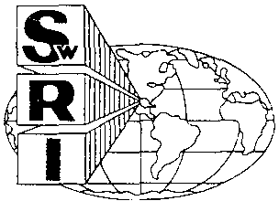

SOUTHWEST RESEARCH INSTITUTE
6220CULEBRAROAD· POSTOFFICEDRAWER28510 • SAN ANTONIO, TEXAS, USA78228-0510 • (512)684-5111· TELEX244846
CHEMISTRY AND CHEMICAL ENGINEERING DIVISION DEPARTMENT OF FIRE TECHNOLOGY FAX (512) 522-3377
TEST FOR EVALUATING THE SMOKE GENERATION CHARACTERISTICS OF SOLID MATERIALS (ASTM E662-83/NFPA 258)
TEST REPORT
MATERIAL ID: FLAME SAFE - PAPER SAFE SwRI PROJECT NO. 01-3779-389
TEST DATE: JUNE 12, 1991
Submitted by:
GLAYS M. FINLEY
JUNE 1991
Prepared for:
FLAME SAFE CHEMICAL CORPORATION 2653 WARFIELD AVENUE
FORT WORTH, TEXAS 76106
Approved by:,

Alex B. Wenzel, Director Department of Fire Technology for
Dr. Robert E. Lyle, Vice President Chemistry and Chemical Engineering Division
This repon IS for the informalion of the client. "may be used in Its entirely for the purpose of securing product acceptance from duly censthuted approval authorities, Neither this reoort nor the name of the Institute shall be used in pLtJlichy or advenising,
SAN ANTONIO, TEXAS
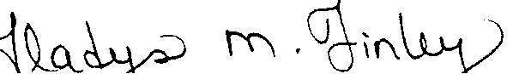
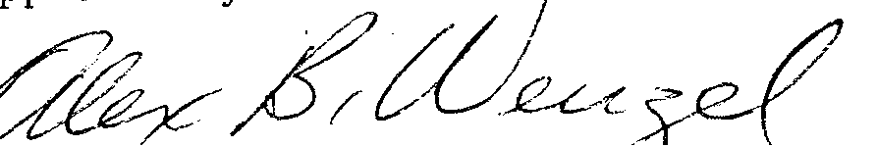
HOUSTON, TEXAS • DETROiT, MICHIGAN· WASHINGTON, DC

The results apply specifically to the specimens tested, in the manner tested, and not to the entire production of these or similar materials, nor to the performance when used in combination with other materials. All test data are on file and are available for review by authorized persons.
This test method is used to determine the smoke generated by solid materials using a Smoke Density Chamber. Test specimens are preconditioned at 410°F (60°F) for 24 hours followed by stabilization at 70°F (21°C) and 50percerifrelative humidity. Specimens measuring 73 x 73-mm are tested in the vertical mode, while exposed to a radiant heat flux of 2.5 watts per square centimeter. Triplicate runs are conducted in each the flaming and nonflaming exposure. Results are expressed in terms of Specific Optical Density (Ds), which is defined as the measure of the amount of smoke produced per unit area by a material due to nonflaming pyrolytic decomposition and flaming combustion.
This report presents the results of a smoke test in accordance with ASTM E662 "Standard Test Method for Specific Optical Density of Smoke Generated by Solid
Materials."
INTRODUCTION

SUMMARY OF RESULTS EXPOSURE: FLAMING
2

In all three runs there was ignition on contact and immediate smoke. The flame went out at 20 seconds in Run 1, 15 seconds in Run 2, and 20 seconds in Run 3.
COMMENTS
RUN | # | 1.5 | min | 4 | min | MAX | Ds | Time | to | MAX | Ds | MAX | Ds | (corrected)
 |  |  |  |  |  |  |  | (min:sec)
------ |  | ------- |  | ------- |  | ------ |  | ------------- |  |  |  | ------------------
1 |  | 31. 9 |  | 71. 9 |  | 77 .2 |  |  | 5:20 |  |  |  | 75.1
2 |  | 30.3 |  | 62.8 |  | 70.3 |  |  | 6:10 |  |  |  | 69.8
3 |  | 25.5 |  | 61.5 |  | 67.9 |  |  | 6:15 |  |  |  | 66.8
------ |  | ------- |  | ------- |  | ------ |  |  |  |  |  | ------------------
AVERAGE |  | 29.2 |  | 65.4 |  | 71.8 |  |  |  |  |  |  | 70.6
SPECIFIC OPTICAL DENSITY (Ds) DURING 20 MINUTES
Specimen Orientation: VERTICAL
Radiant Heat Flux: 2.5 W/CM^{A}2
SwRI Project No: 01-3779-389 FLAME SAFE - PAPER SAFE
Material Tested:
FLAME SAFE CHEMICAL

~t'1E ~H~FE nl-~ ... 77~-~o~

l~ '_I '_ ... l ;-:} I_I I_I ;:1
FLAt·'lING
I225 I-
250 ...,--------------------------~
\ri 200 e
~ 175~ -
~ 150-
....J -
,3 125-
•...•
t- -
f!, 100-
-
75 -
-
50 -
-
25 -
-
r-, •...• LJ.. •...• r_'
!t!
'."
o RUN
- RUN 2 RUN 3
o
I
I
1
I
I I I
2 .~
TH1E (l1INUTES)
I
I
4
I
I)
5
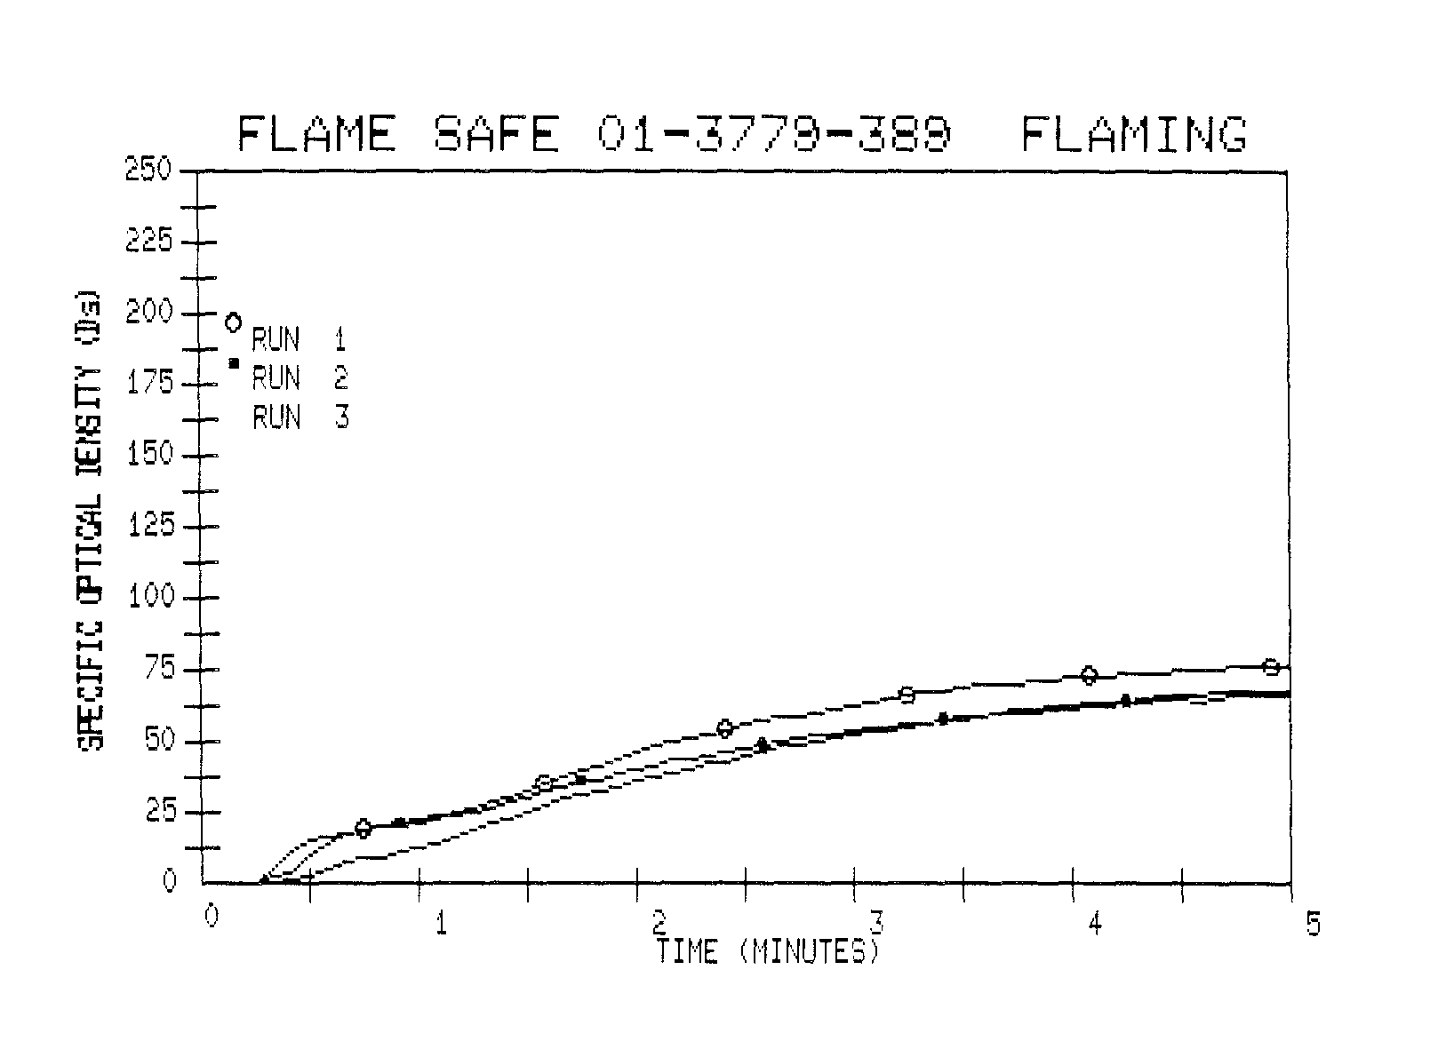
3
F
L
H

4

COMMENTS

Surface char was noted at 15 seconds in Runs 1 and 2, and 10 seconds in Run 3. White smoke occurred at 20 seconds in Runs 1 and 2, and 15 seconds in Run 3. In all three runs, the sample charred through and separated at the end of the test.
RUN | # | 1.5 | min | 4 | min | MAX | Ds
------ |  | ------~ |  | ------- |  | ------
1 |  | 31.9 |  | 56.3 |  | 61.0
2 |  | 31.5 |  | 65.4 |  | 72.4
3 |  | 29.9 |  | 58.0 |  | 63.4
------ |  | ------- |  | ------- |  | ------
AVERAGE |  | 31.1 |  | 59.9 |  | 65.6
6:40 6:55 6:40
Time to MAX Ds (min:sec)
64.6
59.3
71.8
62.9
MAX Ds (corrected)
SPECIFIC OPTICAL DENSITY (Ds) DURING 20 MINUTES
Specimen Orientation: VERTICAL
Radiant Heat Flux: 2.5 W/CM^{A}2
SwRI Project No: 01-3779-389
FLAME SAFE - PAPER SAFE
Material Tested:
FLAME SAFE CHEMICAL
SUMMARY OF RESULTS EXPOSURE: NON-FLAMING

FLAtv1E
250....,.----------------------.
r·,·JIJN-FLAr^{v}1 I NG
 | 225
.-. | 200
'11 |  | o RlJri
5 |  |  | 1
:>- | 175 | • RUN | 2
~
~ |  | RUfl | 3
~ | 150
....I
.3 | 125
•....•
t-
'=' | 100
'-'
•....•
LL.. | 75
•....•
'-'
~ | 50
o:n
 | 25
 | 0
 | 0
...---
-----~ -
-_ ..
--
2 3 THiE U1H1UTES)
4
5
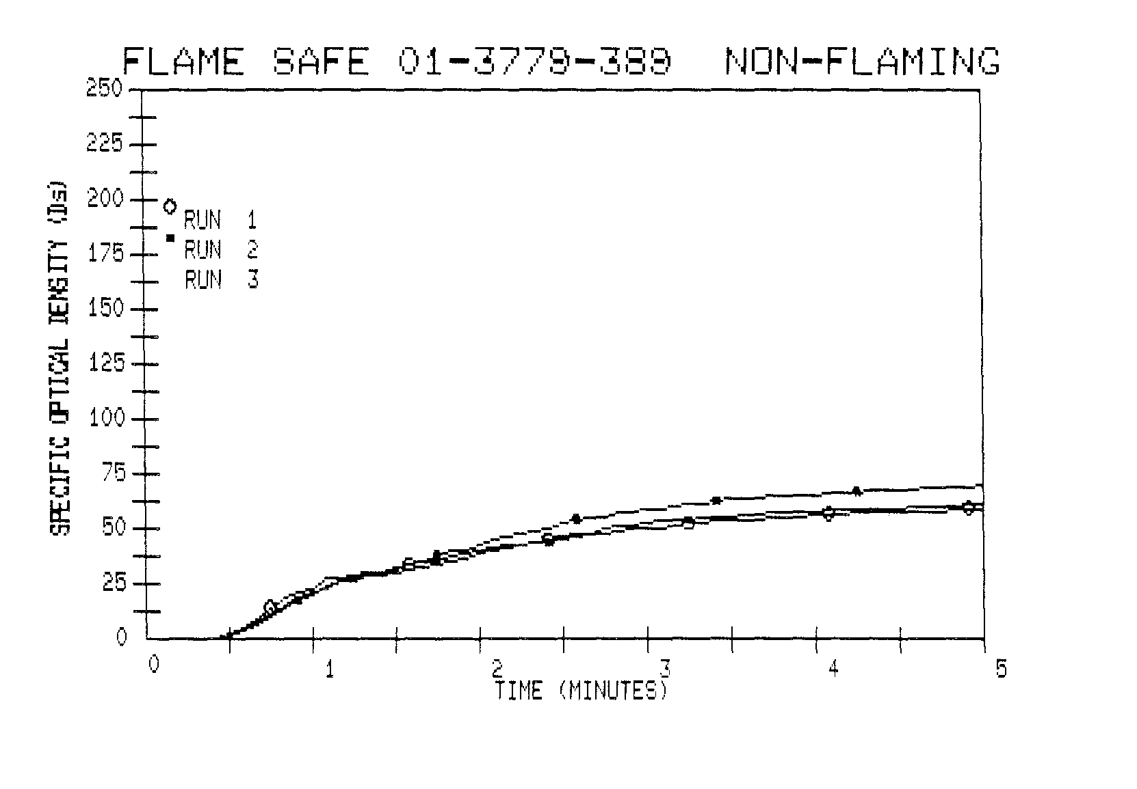
5

